

Structural Design

(Inside View)

**Vertical corrugation**

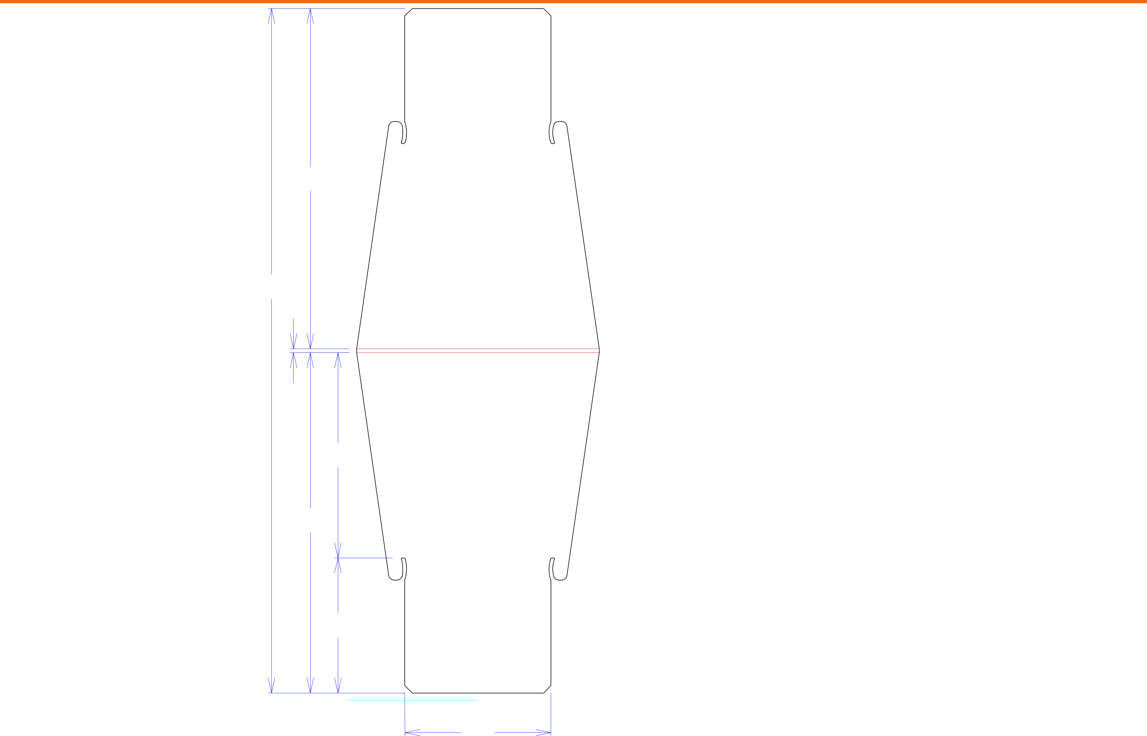

Design#:

|  |  |  |  |  |  |  |
| --- | --- | --- | --- | --- | --- | --- |
|  |  | 23 |  |  |  |  |
|  |  | 461*/*4 |  |  |  |  |
|  |  | 1*/*4 |  |  |  |  |
|  |  | 137*/*8 |  |  |  |  |
|  |  | 23 |  |  |  |  |
|  |  | 91*/*8 |  |  |  |  |
|  |  |  | 97*/*8 |  |  |  |
| Cut | Crease | Crease with Matrix | Cut Crease | Half Knife Cut | Tear Tape | Perforation |



**130331-03**

Customer:

**DeMet's Candy**

Description:

**Header - 5oz Flips qtr plt**

**SINGLE-OUT DRAWING**

Qty/Unit: **1**

Style: **NJDC**

Board: **32 B CT (BTK40L)**

I.D. : **23 x 9+7/8 x 9+1/8**

Area of Blank - Waste : **4.08 sq. ft.**

Waste on Blank : **22.37%**

Finished Piece Weight: **0.43 lbs./195.12g**

Over-all Blank: **46+1/4 x 16+3/8**

**D/C From Label Side**

Notes:

**can be shaped but should be clear of product access**

Revision Info: **[0] 04/10/2013**

Designer: **Alan Groff**

Designright and Copyright of DS Smith Corrugated Packaging Ltd. This technical Specification is subject to Manufacturing tolerances. Drawing dimensions shown are crease to crease. Date printed: 03/10/2021